Logo%20Main%20200

**Boston University**

**Electrical & Computer Engineering**

**EC464 Capstone Senior Design Project**

User's Manual

ClearSol



Submitted to

Malay Mazumder

8 St. Mary’s St Boston, MA 02215, Room 514

(617) 353-0162

mazumder@bu.edu

by

Team 29

ClearSol

Team Members

Zachary Capone [zcapone@bu.edu](mailto:email1@bu.edu)

Fabio Amado [famado@bu.edu](mailto:email1@bu.edu)

Julian Leguizamon [julianle@bu.edu](mailto:email1@bu.edu)

Ryan Rosenberger [rjrose@bu.edu](mailto:email1@bu.edu)

Anthony Saab [saabanth@bu.edu](mailto:email5@bu.edu)

Submitted: Mar 25, 2022

#### ClearSol User’s Manual

#### Table of Contents

Executive Summary ii

1 Introduction 1

2 System Overview and Installation 2

2.1 Overview block diagram 2

2.2 User interface. 2

2.3 Physical description. 2

2.4 Installation, setup, and support 2

3 Operation of the Project 3

3.1 Operating Mode 1: Normal Operation 3

3.2 Operating Mode 2: Abnormal Operations 3

3.3 Safety Issues 3

4 Technical Background 4

5 Relevant Engineering Standards 5

6 Cost Breakdown 6

7 Appendices 7

7.1 Appendix A - Specifications 7

7.2 Appendix B – Team Information 7

(Right click on Table of Contents to update fields and page numbers automatically)

# Executive Summary

ClearSol is a self-contained solar energy system in which a self-cleaning Electrodynamic Screen (EDS) is applied over the solar panel. When dust accumulates on the panel, the film can be charged for a few minutes, clearing the dust off the panel. Clearsol also implements a supercapacitor energy storage system, allowing for better performance under a wide temperature range. We aim for our design to be fully self-contained, capable of operating in an extreme range of temperatures, and able to power the EDS by itself as well as able to output a steady supply of electricity to a load.

# Introduction

Since the beginning of long-term extraterrestrial applications for technology, solar energy has led the pack as a seemingly inexhaustible source of energy from the sun. The lack of atmosphere means panels are even more efficient since there is no reduction in the power of the solar radiation due to absorption, scattering and reflection in the atmosphere. The result serves as the perfect way to power martian rovers, such as the Perseverance.

Unfortunately, the application of this technology is not without its flaws, as the harsh frozen desert of Mars constantly throws dust on top of the panels, cutting their efficiency and reducing the electricity given to the rover. Solar panels on Earth in the places they are most efficient, such as deserts, have this issue as well. The difference is that terrestrial applications have the capability to clean the panels with water. Unfortunately, the nature of extraterrestrial travel does not allow for this to be an option.

In the absence of the ability to wash the panels, ClearSol seeks to utilize an Electrodynamic Screen, developed by Professor [Malay Mazumder](mailto:mazumder@bu.edu) in the Boston University ECE department, to create a self-enclosed system that uses high-voltage static electricity to charge and repel dust from the surface of the panel with the very electricity it has produced.

As a result of the application of this film, martian rovers will be able to run with a much larger surplus of electricity. This allows for a variety of benefits including higher speeds, the ability to run more equipment at any given time, and wheels with more torque.

In the following manual, we intend to further explain the principles of how the system operates, its capabilities, as well as how it would see more real world applications, whether terrestrial or extraterrestrial.

# System Overview and Installation

## Overview block diagram

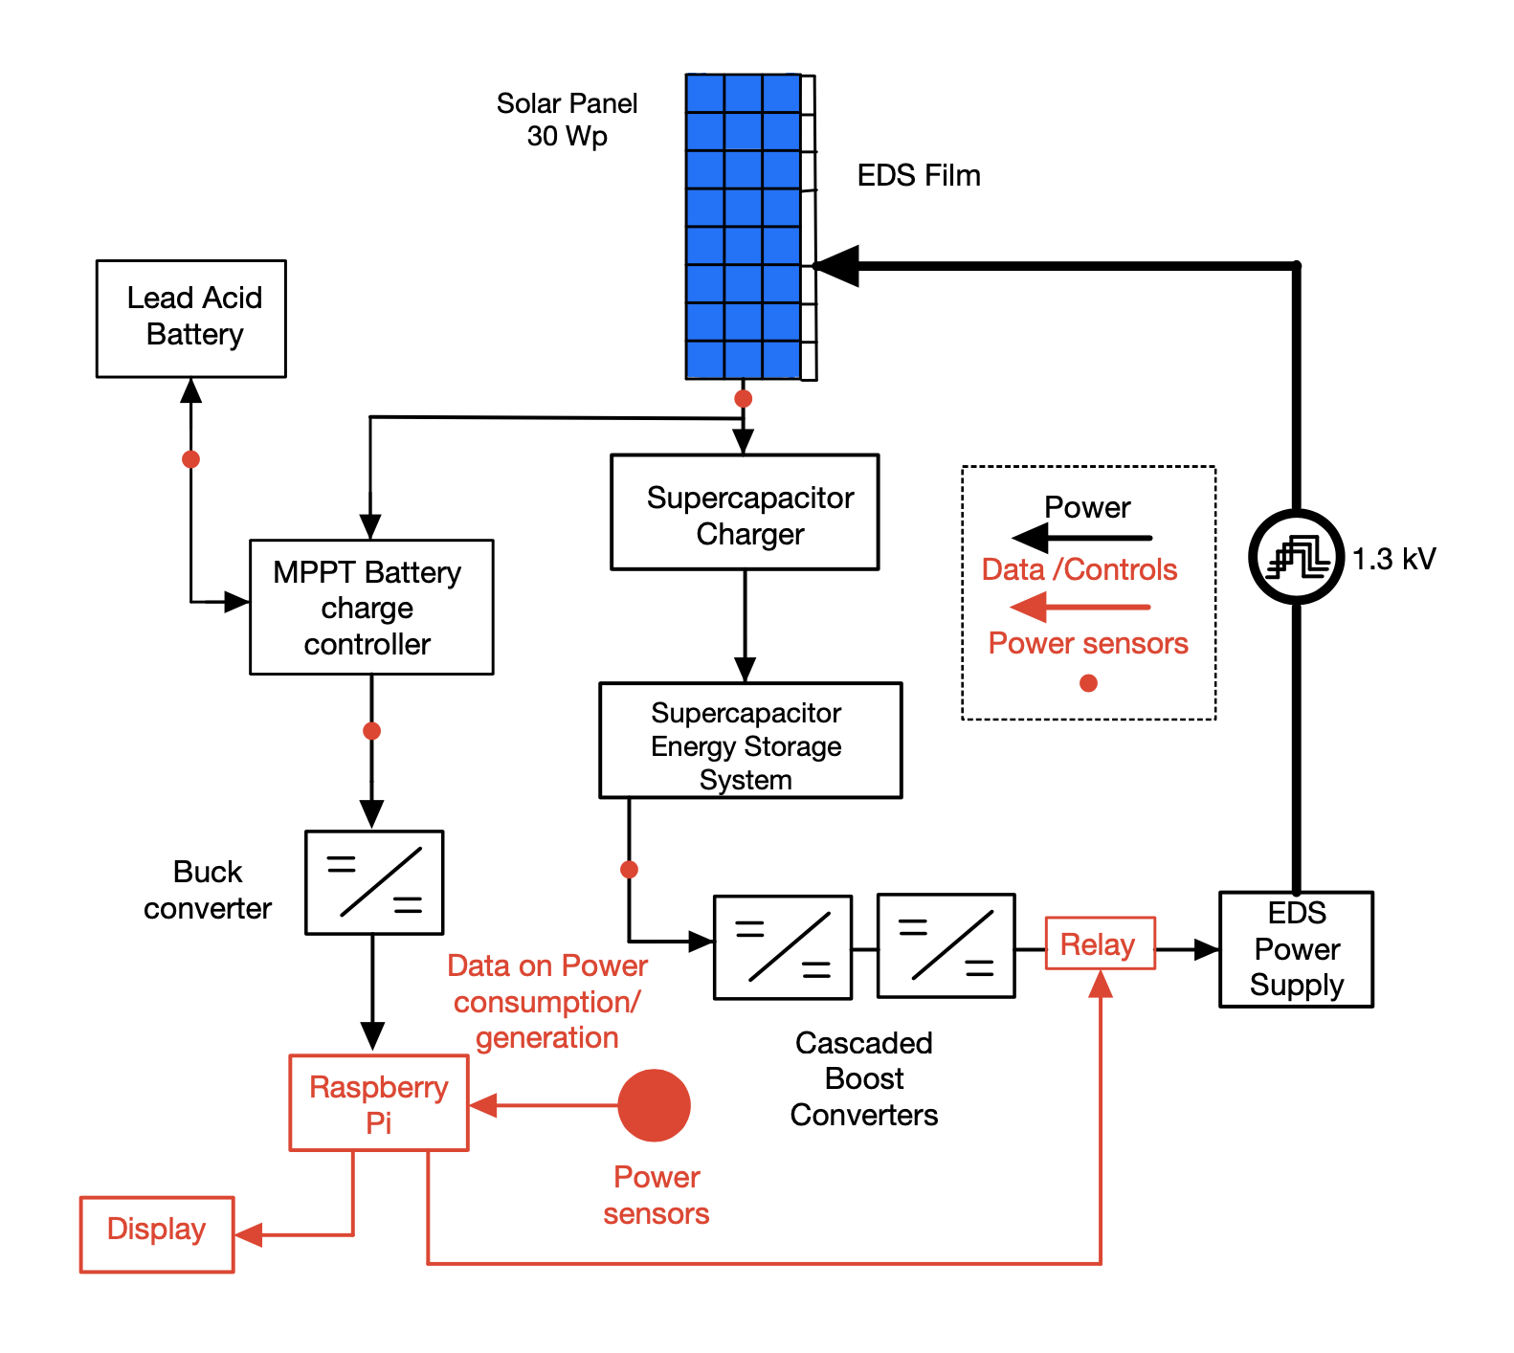

*Figure(): Overall Block diagram of the system showing power flow and controls between components.*

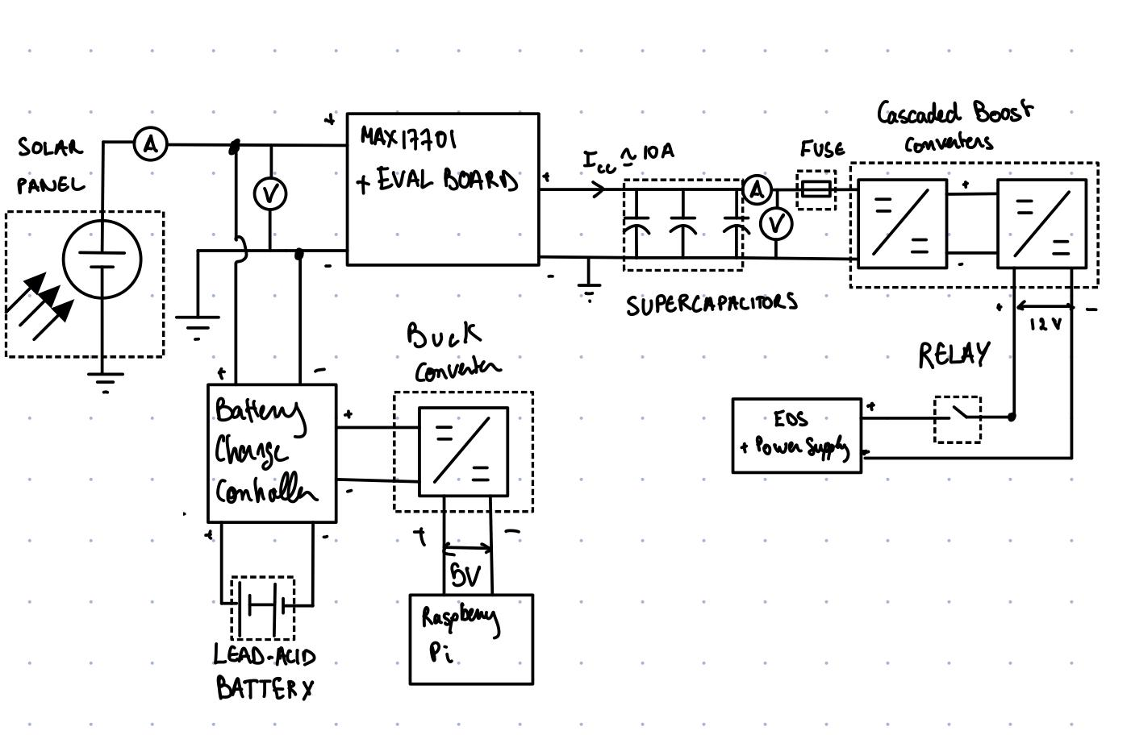

*Figure (): Circuit diagram of our system showing wiring of components.*

## User interface.

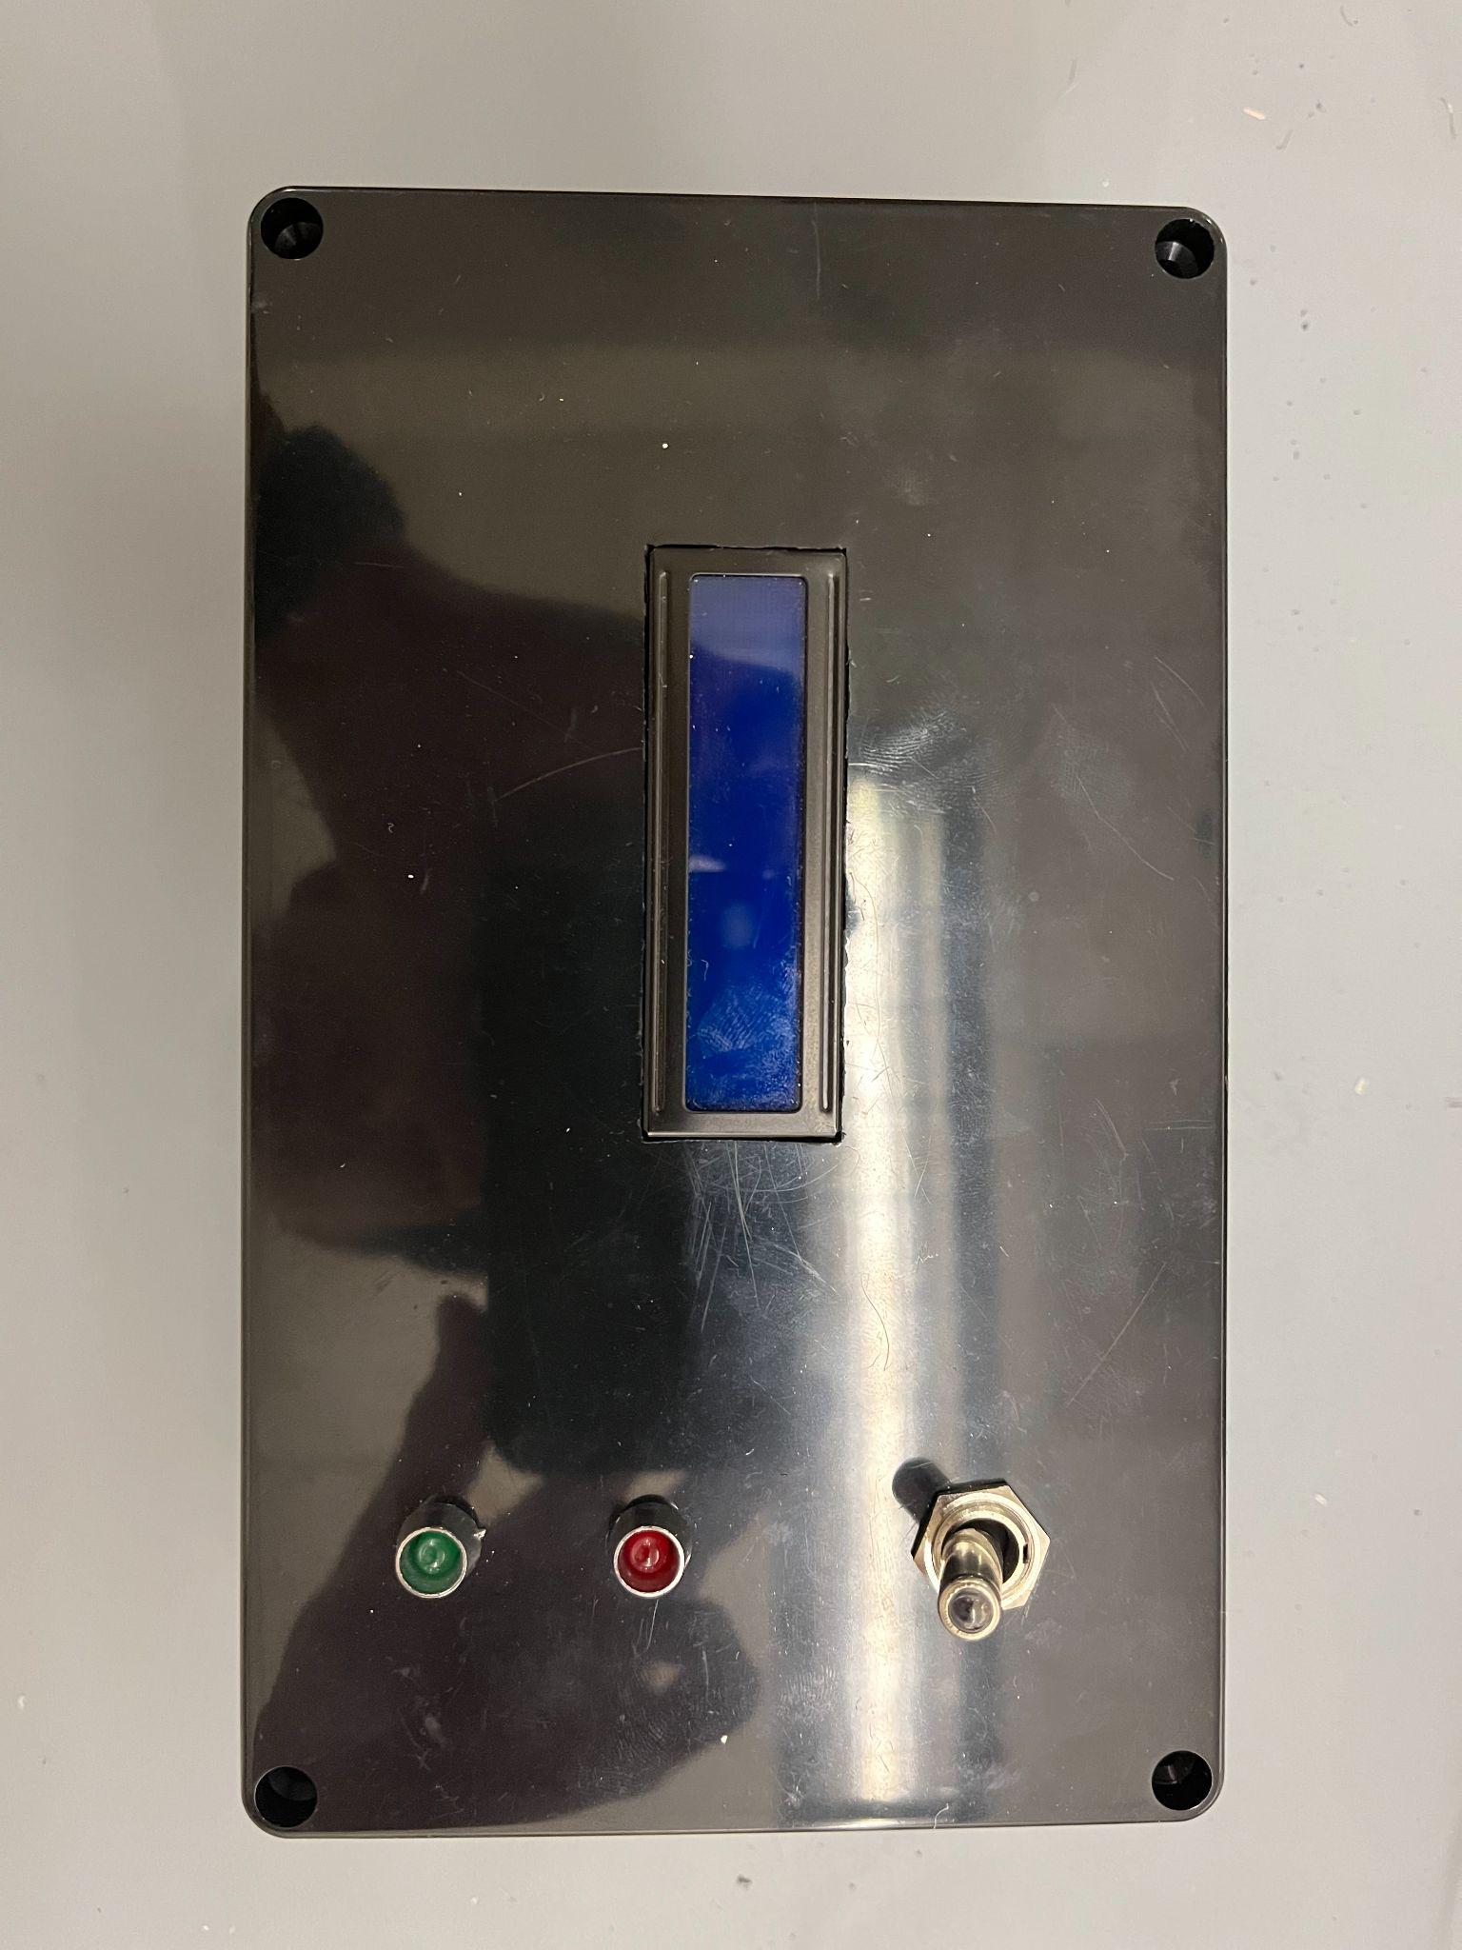

*Figure (): The black box on the side of our containment unit will be the main way the user will be able to talk to our system. The user will be able to see the power output of the solar panel from the LED screen and will be able to toggle on and off the system/EDS screen from the box as well.*

## Physical description.

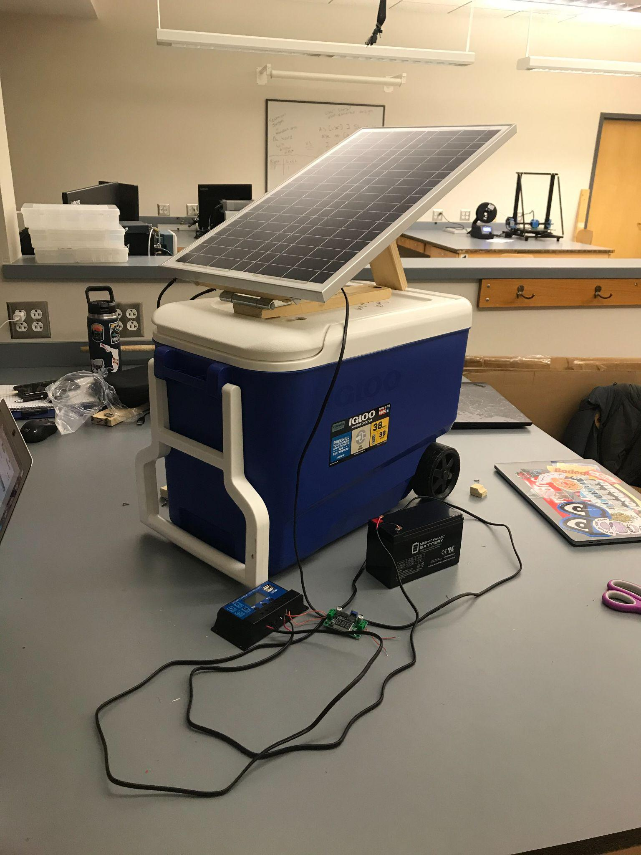

*Figure 1.2: Photograph of the assembly detailed below.*

In order to save money and keep our project as simple as possible, our physical chassis is built and centered around an Igloo beach cooler. The decision to use a beach cooler as the physical chassis due to it already having an insulated body. It can provide protection against different temperatures and weather conditions. It also comes pre-equipped with a towing handle and wheels to make transportation of the unit easy.

On the top of the assembly, a straight line of holes is drilled going across the top. After this hard plastic was breached, boards were sandwiched around these holes, and screws were then used to ‘bite’ the pieces of wood together. As a result, a wooden rail is attached to the top of the cooler. This is the mounting point which is utilized to mount the solar panel as well as the hinges and locks that allow its angle to be adjusted.

On the interior of the assembly, we used a paper rack as the main mounting point for our actual circuit. The idea is that if work or modifications need to be made on any component within the cooler, the rack could be pulled out via a strap running across the top, and the drawers within the rack could be slipped out in order to provide easy access to any component of any part of the overall electrical system. In order to make connecting the portions of these different racks easy, holes are drilled into each drawer in order to provide the user the ability to route cables between levels while still inside the removable rack.

The outside of the circuitry system has very few external connections. In order to tie everything together, two holes are drilled through the cooler itself to allow wire routing. The first is the hole on the top, allowing for the output cable from our solar panel to run to our inverter inside of the case. The second is not visible as it is on the side of the case under our control box. This hole was made so that wires could connect from our control panel box into the contents of the cooler, allowing the user to directly toggle the film, or in our case the unspecified 12vDC output, on and off. Wires will run through in order to connect to our LCD screen, which can be toggled to show information regarding the current voltage within the system.

## Installation, setup, and support

In order for the system to function, it is necessary that the solar panel is exposed to a powerful light source, such as the sun or a high wattage LED lamp. The secondary circuit to the voltaic film through its power supply (in this case our 12v DC dummy load) must also be engaged. Once the LED screen and the lights on the side of the panel box come to life, it signifies the unit is receiving enough power to function and diverting power to the dummy load.

In terms of operating temperatures, our assembly is very versatile. The largest factors to be considered are the super capacitors, which safely operate between the range of -40 and 70 degrees celsius. Although the martian surface stays at -60 degrees celsius, the insulated nature of the physical chassis covering the circuit would easily allow it to warm itself in order to stay within range. Additionally, the large surplus of power the circuit creates means that it would be easy to attach additional resistors or other heat-producing components in order to keep the circuit warm and functional.

# Operation of the Project

## Operating Mode 1: Normal Operation

The normal operation of the project will mostly be automatic and require little user input.

In a normal operating mode, a user will interact with the system as follows:

1. Place the unit in an area with plenty of sunlight and sun exposure.
2. Adjust the panel angle using the wooden stand in order to maximize the sunlight the panel receives.
3. The unit as of now needs an external power source in order to power the 5V raspberry pi. Make sure you are near an outlet and plug in the pi.
4. To alternate the reading mode of the system simply press the button and the LCD screen should alternate to read values for power output.
5. The system will be running and charging the supercaps. The EDS film is set to go off at intermediate times throughout the day.
6. To activate the EDS manually, simply flip on the black box.

## Operating Mode 2: Abnormal Operations

An abnormal operation state for the system is when energy storage (supercaps) becomes fully discharged. To get out of it, allow for the system to recharge with sunlight. Supercaps cannot be charged any other way.

If we incorporate the lead acid battery to power the Raspi, there is a similar issue. The LCD display would not get enough to show power flow, so the unit needs to be in an area with a considerable light source.

Anticipated abnormal states for the project is, the system losing power from being fully discharged. As the energy storage (supercaps) becomes fully discharged, there is no other way to charge them but with sunlight. The monitoring system would also lose power and not display the data when it has no power and it would only power on after being in considerable light.

## Safety Issues

This project involves the storage of a considerable amount of energy in supercapacitors and batteries. There is a risk that energy will be quickly dissipated unintentionally.

A significant risk comes with the supercapacitors specifically. Each one of our supercapacitors can sustain a peak current of 180 Amps. If they are accidentally shorted, the shorting instrument may become incredibly hot, vaporize, or explode, posing a risk to surrounding parts of the system and to any nearby people. Once the system is complete, the supercapacitors will be placed inside an enclosure so that risk to human life is reduced and risk of fire to surrounding areas is reduced.

Maintenance risk is another aspect of the project. We have some countermeasures in place, such as having a fuse in series with the supercapacitor storage to reduce the risk of shorting. But, there is a possibility that a wire, screwdriver, or other conductive object shorts the terminals of the capacitor. As a basic safety measure, it is advised to wear safety glasses when interacting with charged supercapacitors. Ideally, the project will move to a stage where the supercapacitors are enclosed and are not being actively worked on quickly so that maintenance risk is reduced.

The connections to the supercapacitor storage bank are fused to prevent risk of shorting during system operation. Additionally, the power conversion stages in our system that are connected to our supercapacitor storage have current limiting capability should a short arise.

Safety issues regarding the EDS power supply (providing a 1.3kV three phase square wave) are a concern in this project. Unfortunately, we were unable to attain a functional EDS power supply and were not able to add this section to the project.

# Technical Background

*4.1 Monitoring system*

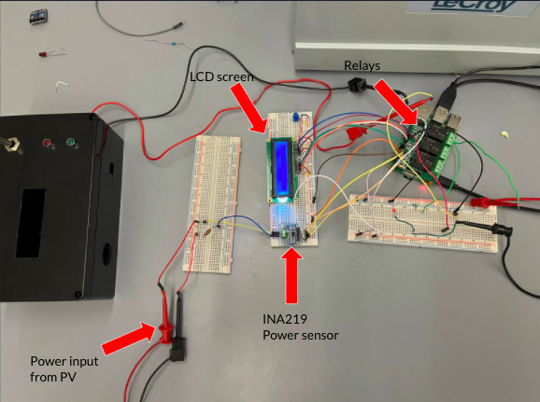

*Figure (): This is a breakdown of the components involved in our monitoring system.*

Our monitoring system has two main goals: to measure the power output of the solar panels and to be able to activate and deactivate the EDS screen. We use INA260 power sensors to measure the current and voltages within our system. Our raspberry pi 4 samples these measurements around every 1 second and is able to calculate the power in watts coming from the solar panel into our system. A 7-segment display is connected to our pi and displays the current and voltage being produced. The relays are on a HAT module and connected to the pi via GPIO connections. When our code detects that it is time to activate the EDS, we use the pi to flip the relay that is connected to the 12V EDS power supply to turn it on for a period of approximately 2 minutes. Additionally, the EDS can be activated manually by flipping the switch on the black box. This switch is connected to the pi via GPIO pins and will trigger the relay when pressed. Our monitoring system as a whole consists of 4 INA260 sensors. These sensors are soldered on a single PCB board and are measuring the voltages and currents of different parts of our system. These different parts include, the solar panel input, supercapacitor input, supercapacitor output, and the EDS load. By pressing the yellow button on the black box the user is able to flip between these sensors and see the voltage and current for each one.

*4.2 Power System*

The overall aim of our power system is to take energy from incoming sunlight, store it, and use it to power an electrodynamic screen. We utilize a polysilicon solar panel to convert incoming light into electricity. This generated power is then converted and then stored in a bank of supercapacitors. When triggered by the monitoring system, power is drawn from the supercapacitor bank and converted again before being delivered to the load.

We utilize a buck converter to reduce the solar panel output voltage to be compatible with our supercapacitor charge controller. The charge controller charges the supercapacitor bank to 2.7V. From the supercapacitor bank, there are two cascaded boost converters which convert the supercapacitor voltage (0.5-2.7V depending on the state of charge) to our desired load voltage (12V).

Additionally, our system also stores energy in a lead acid battery, to be used in the monitoring system. A charge controller connects to the solar panel and charges the lead acid battery to roughly 14 Volts. From there, a buck controller converts the 12-14V output of the battery to 5 Volts, for the raspberry pi of our monitoring system. A set of relays connects either the supercapacitor charge controller, or the battery charge controller, to the solar panel.

# Relevant Engineering Standards

The most relevant engineering standards for this project fall under the solar photovoltaic industry. The standards priorities for the industry are safety first, hierarchy of standards and codes effort, and product testing and labeling. If a solar system is not connected to the grid, it must have its own storage system.

There are three focus standards for the project. The primary focus for the project is to make sure it follows the Electrical, Mechanical, and Fire Safety standards. The secondary focus is to make sure it follows Solar Module Model Pass-Fail Qualification and Single-Point, New Module Electrical Rating.

In the USA, the primary source of PV safety standards is the Underwriters Laboratories (UL) and the Institute of Electrical Engineering and Electronics (IEEE). The Underwriters Laboratories (UL), an independent safety science company, develops standards, product requirements, testing, and certification processes for ensuring various products meet safety standards. In addition to certifying PV installers, UL tests and certifies solar PV modules in accordance with the National Electrical Code and Model Building Codes. UL 1703 provides a process for testing minimum safety and performance standards for PV modules, ensuring the equipment mitigates mechanical, electrical, and fire hazards, and performs according to minimum standards.

The testing process includes several environmental tests to make sure the module does not break or degrade under typical operating conditions. UL has also developed processes to test PV components, including electrical components, inverters, interconnection equipment, rack mounting systems, and trackers (used in some large-scale PV systems). UL 1741 provides UL’s process for testing standards for inverters, converters, controllers, and PV interconnection system equipment. These standards are published under the American National Standards Institute’s (ANSI) accredited process for Standards Development Organizations.

The Institute of Electrical and Electronics Engineers (IEEE), a professional society, develops industry-driven consensus standards on equipment, including PV system grid integration and energy storage devices. IEEE 1547 articulates the widely adopted standard for interconnecting a rooftop PV system to the electric grid. Key provisions in IEEE 1547 include voltage and frequency trip thresholds, disconnection, grounding, monitoring, and islanding requirements—in short, the technical standards that provide safety and performance assurances so grid-connected PV systems do not create safety or reliability problems for grid operators or consumers. The Energy Policy Act of 2005 set IEEE 1547 as the national standard for interconnecting rooftop solar PV systems (and other distributed generation resources) to the grid, and many states and utilities have adopted IEEE 1547 as part of their interconnections standards.

Third-party equipment standards, including UL 1703, UL 1741, and IEEE 1547, are applied in conjunction with and as a complement to one another and electrical and fire codes. For example, UL 1741 is intended to be jointly used with IEEE 1547, and the products covered by UL 1703 and UL 1741 are intended to comply with the National Electrical Code, NFPA 70.

The Solar Module Model Pass-Fail Qualification is a series of pass-fail torture tests designed to identify near-term failures in the new model of PV module. The specific series of test are specified in standards of the IEC:

– IEC Standard 61215 (modules with silicon crystalline cells)

– IEC Standard 61646 (modules with thin-film cells)

These two IEC standards reference several other related IEC standards such as UV tests, NOCT/outdoor tests, damp heat/thermal cycle/HF test, mechanical load, hail test, and light soaking. The solar module used by the project is a tested product delivered by Poly Solar and it follows these standards as it is being marketed and sold commercially.

# Cost Breakdown

| Project Costs for Production of Beta Version (Next Unit after Prototype) | | | | |
| --- | --- | --- | --- | --- |
| Item | Quantity | Description | Unit Cost | Extended Cost |
| Solar Panel | 1 | POLY SOLAR PANEL - 30W | $0 | $0 |
| Raspberry Pi | 1 | Raspberry Pi4 Microprocessor | $0 | $0 |
| Supercapacitors | 4 | 4 Kyocera 400F supercaps | $15.20 | $60.69 |
| Supercap Charge Controller | 1 | Maxim Integrated MAX17701EVKITA | $69.66 | $69.66 |
| Buck converter | 2 |  | $9.99 | $19.98 |
| Low V boost converter | 1 | TPS61022EVM 8-A ultra low input voltage | $69.69 | $69.69 |
| High V boost converter | 1 | BQ25173EVM | $59.06 | $59.06 |
| Lead Acid Battery | 1 | 7.2 Ah 12 V Lead-Acid Battery | $17.50 | $17.50 |
| Battery Charge controller | 1 | Wanderer Charge Controller | $0.00 | $0.00 |
| Cooler | 1 | Enclosure | $15.00 | $15.00 |
| Wood | 1 | Panel mount material | $9.99 | $9.99 |
| Hinges | 2 | Panel mount hinges | $4.89 | $9.78 |
| Inverter | 1 | To power an optional AC load | $30.00 | $30.00 |
| STM32 Microcontroller | 1 | (optional) Low power microcontroller | $34.99 | $34.99 |
| Beta Version-Total Cost | | | | 378.84 |

The budget estimate for the project isn’t complete as some of the parts used were found as extras from previous years’ projects. As such, the value of the items are listed as zero for the moment but will later be corrected for the unit value of the specific item used in previous years.

In the beta price, we include the cost of eval/development boards. In an actual beta, we might build out our own board/PCB, which can save a significant amount of money. As such, it should be treated like an overestimate.

If the project is to be scaled up, the cost breakdown would need to be adjusted in the future revisions. We would need to factor in our runtime calculations to estimate how many more supercaps we would need. We would likely also cut some elements necessary for the battery storage piece. There would need to be a higher current charger adapted for higher capacitance. Additional safety components could be added with no need for a lead acid battery. Larger panels make sure the capacitors are always charging.

Reasons not to improve currently, are that a larger supercap bank would have additional needs when it comes to charging. There also would be a need for more time and to modify many elements of our system.

# Appendices

## Appendix A - Specifications

| Requirement | Value, range, tolerance, details |
| --- | --- |
| Load Voltage | 12V |
| Continuous load current | 125mA |
| EDS runtime on one charge | <2min |

## Appendix B – Team Information

Zachary Capone is a graduating Electrical Engineer who intends to move out west and work to attain a PE certification. He will not be making this move until he completes one last course during Summer 1, as this will complete his computer engineering minor. However, with the completion of this Capstone with the team, he is proud to say he has obtained a bachelors in electrical engineering from Boston University.

Fabio Amado is with the Department of Electrical and Computer Engineering, Boston University, Boston, MA 02215. He worked on the data monitoring aspect of the project and documentation of notes. He held the responsibility to make sure the system in different scenarios can monitor and output data to the monitor. He plans to keep working on clean technologies and energy solutions. He plans to use his skills as an engineer to help reduce the strain on the planet and continue to solve environmental problems.

Julian Leguizamon is a senior with the Electrical and Computer Engineering department studying Electrical Engineering. After graduation, Julian plans on moving to Dallas, Texas and work with the consulting firm Accenture.

Anthony Saab is a senior in electrical engineering at the ECE department at Boston University. He is looking to work in the renewable energy industry after graduation.

Ryan Rosenberger is a senior with the Department of Electrical and Computer Engineering at Boston University. He is planning on pursuing graduate studies with a focus on power electronics and renewable energy systems.